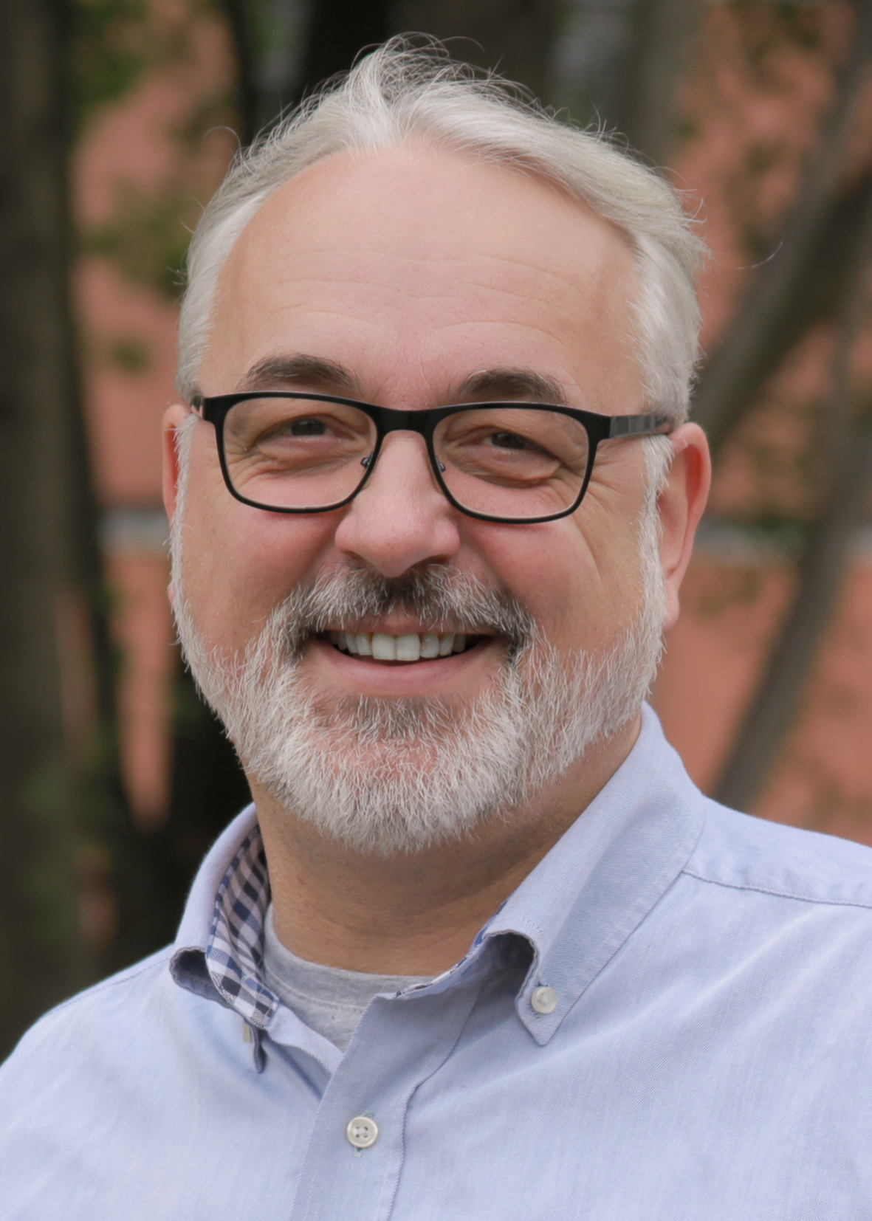

**PERSON**

**Name** Mike Guwak

**Address** Sachsenring 13a,

65817 Eppstein - Germany

**Phone**+ 49 1573 | 764 92 89

**E-Mail** [info@mikeguwak.de](mailto:info@mikeguwak.de)

**Website** [mikeguwak.de](https://mikeguwak.de/)

**Born** on 4 April 1971 in Marburg, Germany

**Nationality** German

**Marital Status** Divorced, one child

**CORE COMPETENCES**

* **Management & structuring of IT operating units**
* **Introduction & optimisation of IT service processes (ITIL-based)**
* **Strategic further development of IT infrastructures**
* **Creation & maintenance of emergency plans, operational documentation**
* **Coordination of service providers & external partners**
* **SLA-/KPI-supported service monitoring**
* **Interface management between IT & specialist departments**
* **Analysing & improving internal IT processes**
* **Design & implementation of technical solutions**
* **Communication security at all levels**
* **Public tenders (evaluation & technology)**

9

MIKE **GUWAK**

*"Being an experienced IT professional with more than 25 years of practical experience in infrastructure management, system administration and IT service responsibility, I stand for stability, efficiency and high quality standards in IT operations.*

*I combine strong analytical skills with practical implementation expertise - both in corporate structures and in medium-sized companies. My profile is characterised by independent action, a holistic understanding of IT and a technical flair for dealing with complex infrastructures."*

**PROFESSIONAL EXPERIENCE**

**Fibrolux GmbH |** Hofheim, Germany

**Senior IT-Systemadministrator *Since July 2023***

* Responsible for setting up, operating and further developing the entire IT infrastructure
* Introduction of proactive monitoring with Zabbix to monitor business-critical systems
* Maintenance and further development of IT documentation and emergency plans
* Administration of the Microsoft 365 environment with a focus on SharePoint, Teams, Microsoft Defender, Intune and Exchange Online
* Interface function between management, specialist departments and external IT service providers

**SOLVVision AG |** Frankfurt, Germany

**Consultant Infrastructure *January 2023 - June 2023***

* Supporting customers in the analysis and optimisation of their IT infrastructure
* Processing complex tickets in the area of infrastructure via ServiceNow
* Structuring and evaluation of CMDBs to improve data quality
* Conception and development of virtual data centres for enterprise solutions

**Red Reply GmbH |** Frankfurt, Germany

**IT Service Manager *January 2021 - December 2022***

* Monthly creation of SLA reports and service desk evaluations
* Support and maintenance of the Oracle ZFS storage systems
* Responsibility for 2nd level support in the context of business-critical applications
* Introduction of standardised support processes based on ITIL

**NECDIS GmbH |** Frankfurt, Germany

**Senior IT Systems Engineer *July 2019 - December 2020***

* Operation and maintenance of the internal IT system landscape incl. CRM/ERP
* Creation of technical solution concepts for customer projects
* Technical evaluation of public tenders
* Preparation of offers, communication with customers and suppliers
* Coordination with manufacturers and external partners
* Documentation of technical implementations and solutions

**bluetelligence GmbH |** Wiesbaden, Germany

**Quality Manager Enterprise Glossary *February 2019 –***

***June 2019***

* Responsibility for testing the software "Enterprise Glossary"
* Creation of extensive product documentation in a wiki (Atlassian Confluence)
* Support in first level support

**ORACLE Deutschland B.V. & Co KG |** Dreieich, Germany

**Senior Technical Support Engineer *July 2010 - January 2019***

* Support of the following Oracle products: SL8500, SL4000, SL3000, SL150, L500, L700, SL24/48, StorageTek SAM-FS/QFS software, Solaris
* Fault diagnosis with Remote Support WebEx or SDP2
* Provision of problem isolation and resolution for very complex problems
* Support for possible future problem determination/solution

**Sun Microsystems GmbH |** Langen, Germany

**TSC Engineer CT3 *October 2000 - June 2010***

**GE CompuNet |** Frankfurt, Germany

**System Engineer Support Services *October 1996 -***

***September 2000***

**Systematics Rhein-Main |** Wiesbaden, Germany

**System Technician *November 1995 - September 1996***

**Henning Sicherheit GmbH |** Hainburg, Germany

**Energy Electronics Technician *November 1994 –***

***February 1995***

**Siemens AG |** Frankfurt, Germany

**Energy Electronics Technician - Systems Engineering**

***June 1992 - October 1994***

**EDUCATION**

**Siemens AG |** Frankfurt, Germany

**Apprenticeship - Energy Electronics Technician**

***Specialising in Systems Engineering***

***September 1988 - June 1992***

**Konrad-Haenisch-Schule |** Frankfurt, Germany

**High School Certificate**

***1982 - 1988***

**CERTIFICATIONS**

* **Microsoft Defender - Fending Off Threats**
* **Microsoft Teams, Intune, Sharepoint Online**
* **Zabbix Monitoring - Introduction & Operation**
* **Nginx - High Performance Web Server**
* **Fail2Ban - Protection Against Brute Force Attacks**
* **Veeam Backup & Replication - Compact Course**
* **Microsoft Azure - Basics & Administration**
* **Windows Server 2022 - Administration**

**IT SKILLS**

* **Operating Systems**: Windows Server, Linux (Debian, Ubuntu)
* **Cloud & Microsoft**: Microsoft 365, Azure, Intune, SharePoint, Teams
* **Backup & Recovery**: Veeam, Oracle ZFS Storage
* **Monitoring & Logging**: Zabbix, Nginx, Fail2Ban
* **Network & Security**: Firewall configuration, access controls
* **Service & Ticketing**: Jira, Jira SM, Confluence, ServiceNow
* **Scripting & Automation**: PowerShell (basics), Bash
* **Virtualisation & Infrastructure**: setting up virtual data centres

**REFERENCES**

*Available on request*